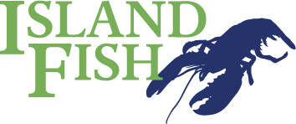
Eat in Menu
The following items are available all day. Subject to weather and what we catch! Please order at the counter – thank you
Lobster or Crab Sandwich £7
Potted Crab, Salad, Slaw & Artisan Roll £10
Lobster Salad/Dressed Crab/Whole Crab Salad £12
Crab Quiche & Salad £7.50
Fish Pie, Salad & Slaw £10
Lobster, Potato Wedges & Slaw £12
Lobster & Bacon Burger, Fries & Slaw £12
Portion of Fries £3.50
Coffee/Tea/Herbal Tea/Hot Chocolate £2.50/£2.75
Lemon/Carrot Cake/Chocolate Brownie £2.50
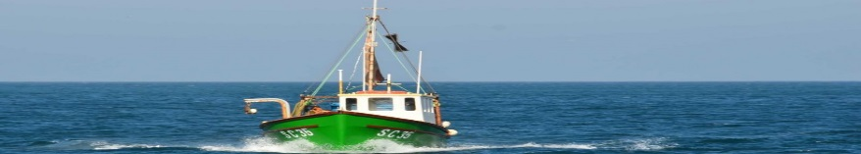
Cold drinks including: Ginger Beer, Rose Lemonade, Victorian Lemonade, Appletise, OJ, Sparkling Elderflower, Mineral Water & Coca Cola/Diet Coke
Assorted Ice Cream

Welcome to Island Fish – we are a small family business based on Bryher. Our family has lived on Bryher for generations, it’s where we work, live and play.
All the shellfish that you eat here today has been caught by us, either by Mark Pender on the Dorothy Ethel -the blue 9 metre boat that you can see in the water by Hangman’s Island, by his father Mike Pender in the Emerald Dawn – the green 7.7 metre boat that he built himself in 1980 or by his nephew Shamus in the Ma Vie.
Everyday Mark, Mike, and Shamus head out to sea first thing in the morning to fish the seas around Scilly, from Bishop Rock to the Eastern Islands. Between them they have over 500 pots that they haul on alternate days, baiting their pots with salted mackerel, ray or scads. At the end of the day they bring their catch ashore direct to Island Fish or store it in wooden boxes called ‘Carbs’ in the waters between Tresco & Bryher.
Each morning Amanda Pender (Mark’s sister) and the team cook and pick the catch from the previous day, ensuring that enough is picked by 7.00 each morning (we start at 5.00) to enable us to start prepping and cooking everything that you can see in our cabinets and on our menus. We carry on picking crab throughout the day to try to ensure that we have enough to go round – we pick every little bit of the crab by hand, it is a tedious and time-consuming task but we hope you will agree that the end result is worth it - a true taste of Scilly: shellfish - caught, cooked, picked and served by us - the Pender family of Bryher.

